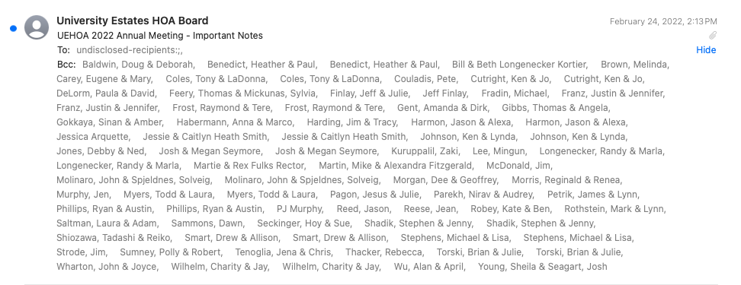

Neighbors,

Thanks to those that attended our annual meeting this past Sunday!  We had a great meeting, although only a small percentage of the neighborhood showed up, which was disappointing.  We'd like to know for next year if a weekday night is preferable, or more reminders are needed.  Please respond if you have thoughts on this.

During the meeting it was requested that we send out a neighborhood directory.  It is attached to this email - let us know if any updates are needed.

It was also asked that we send the links for our website and facebook groups.  We are a very small board, so information may not always be up to date.  If anyone has experience and wants to volunteer- we'd greatly appreciate it.

<https://www.uehoa.org/>

<https://www.facebook.com/UniversityEstatesHOA>

<https://www.facebook.com/groups/891530630898563>  (not sure if this link will work- if not search "University Estates: Special Announcements and Events")

Below is the agenda from the annual meeting.  If you have any questions, please reach out to us.

* 2022 Dues - Invoices will be going out next week.
  + Phase 1 = $125.00
  + Phase 2 (Walnut Ct) = $75.00
    - Phase 2 dues are locked in at $75.00 thru 2023.
* 2022 Elected Officers
  + Austin Phillips - President
  + John Wharton - Vice President
  + Treasurer - Ken Cutright
  + Secretary - Julie Torski
  + Member - Dee Morgan
  + Member - Jim Strode
* Unfinished Business.
  + Projects In Our Area
    - Townhomes behind Walnut Court.
    - Kershaw & Greene Apartment- development at the base of the neighborhood on St. Rt 682
    - Open lot at the entrance, sharing a parking lot with the medical office, will be developed this summer- more details below.
  + Landscaping/ Entrance Building - looking for bids for affordable landscaping companies.
  + American Flag & OU Flag - thanks to two generous members that have donated these the past two years.  A new American flag will be going up this weekend.
* New Business.
  + Email vs. Mailing – we will be communicating through email moving forward, other than dues invoices.
  + Mailbox lamp post lights – thank you to all that fixed yours!  We still have some out, and will be contacting those members shortly.  Stay tuned!
  + Speed Bumps - PLEASE use speed bumps as intended, stop driving around them.  Peoples’ curbs are being driven on so tires can avoid the bumps- which is extremely unsafe for walkers.
  + Street Parking - although we do not have jurisdiction over the city streets, we ask that you park in your driveway as much as possible.  It is much safer for members walking, riding bikes, and has a much cleaner and nicer appearance for our neighborhood.  If you choose not to, please be aware there is a city code that states,  "No parking is to exceed 24 hours in the same location on any city street."
  + Mulch - Gary Gitlitz, owner of The Falls Apartments, is now selling mulch.  He wanted to ensure our neighborhood knew for the proximity to our homes.  Please contact John Wharton for more information.
  + Dogs – please clean up after your dogs, and have them on a leash if they do not listen and are likely to attack another dog.  We have had members complain about both issues recently.
* Events
  + Spring Clean-Up/ Pizza Party - TBA
  + Summer Kona Ice Party - TBA
  + Halloween
  + Santa Claus

One thing we just became aware of are the plans for the open lot at the entrance of University Estates that will share a parking lot with the medical building.  Below are some details from the lot owner, Ben Holter.

* Currently in the early design phase of building, estimated ground breaking mid-summer.
* Similar quality construction as the neighboring surgery center (combination of glass, stone/brick, hardie board siding)
* Primary tenant and partner in the project is Shane Foster of Athens Eye Care.
* Approximately 8,000-10,000 sqft of remaining space currently available for medical or professional office use.  Any businesses or individuals interested in leasing space may contact Ben Holter (740-508-0213)

Lastly, Solveig Spjeldnes, our city council representative posted the following on our Facebook page, ‘University Estates: Special Announcements and Events.’

If you’re not on Facebook, we have copied her post below.

At our HOA meeting on Sunday, some news was discussed and concerns were expressed.  Highlights include the following.

* First, our legal issues have been addressed, so legal expenses will hopefully stop. Thanks Austin and the HOA leadership for getting this done!
* Plus, Walnut Ct is now part of the HOA and annual fees are now $125 for existing members and $75 for Walnut Ct residents temporarily.
* Note that Austin Phillips, our HOA President, said that the HOA would make available a directory of email addresses for our residents, which would be great.
* Regarding road issues, I contacted Andy Stone, Athens Service-Safety Director and our Engineering and Public Works Department to follow up. Here are the responses.
  + Speed Bumps - "The street dept. put work order for the speed bumps, street crew ordered anchor bolts for the speed bumps and waiting on them to be shipped."  They are looking into a method for marking the speed bumps so the snow plows are less likely to damage them in the future.
  + Parking and suspicious vehicles on Broadmoor Ct. - Andy Stone wrote that No Parking signs will be placed there. He also is notifying Chief Pyle from a policing perspective on the “No Parking” (and “partying in the field”) issue.
  + UE Blvd Road Repaving - Andy continued "...UE Blvd will be looked at in the citywide rating we do annually to decide where to repave for 2022. If it meets the distress criteria and the annual program supports it, it can be included. If it doesn’t make the cut, i.e. there are worse locations that should take priority, etc, we can re-look it in out years."
  + Bike Path - As you have noticed, the bike path is still a problem. An engineering firm is trying to figure out what to do to manage the natural springs that have undermined the path. Long story. I'll be in regular contact with the EPW Department to get updates.
* John Wharton reported that the new subdivision past Walnut Ct. - Wood's Edge will begin soon. According to my notes, there will be 18 buildings with owner occupied triplexes that have a universal design - meaning that they are ADA compliant. About 3-4 buildings will be constructed per year. The cost will be around $230-$270 per unit. John has the floorplans if anyone is interested. FYI - the location will be down Broadmore then a street will be added on the left. John's assures everyone that the units will not be easily visible from Walnut Ct backyards on that adjacent side.
* The construction across from our entrance on Rt. 682 will result in 2 large apartment buildings with about 100 3-4 bedroom apartments intended for families. Another set of 2 similar apartment complexes are slated to be built next to them towards The Plains after these are completed. This second set of buildings have not been approved yet. This will increase traffic considerably. They will NOT be subsidized housing/HUD housing, per Andy Stone.

Let me know if you have any further questions or concerns. You can  DM me or reach me at [sspjeldnes@athenscitycouncil.com](mailto:sspjeldnes@athenscitycouncil.com) or 740-590-2036

We look forward to serving our neighborhood for another year!

Austin Phillips

UEHOA Board